What We're Going To Cover
- The Media Buyer Onboarding Process
- The 3 Pillars of Media Buyer Success
- The Media Buyer Training Bootcamp
- How to Build Your Bootcamp

The Media Buyer Onboarding Process
So what does the onboarding/ramp up process look like? (Miro board copy)
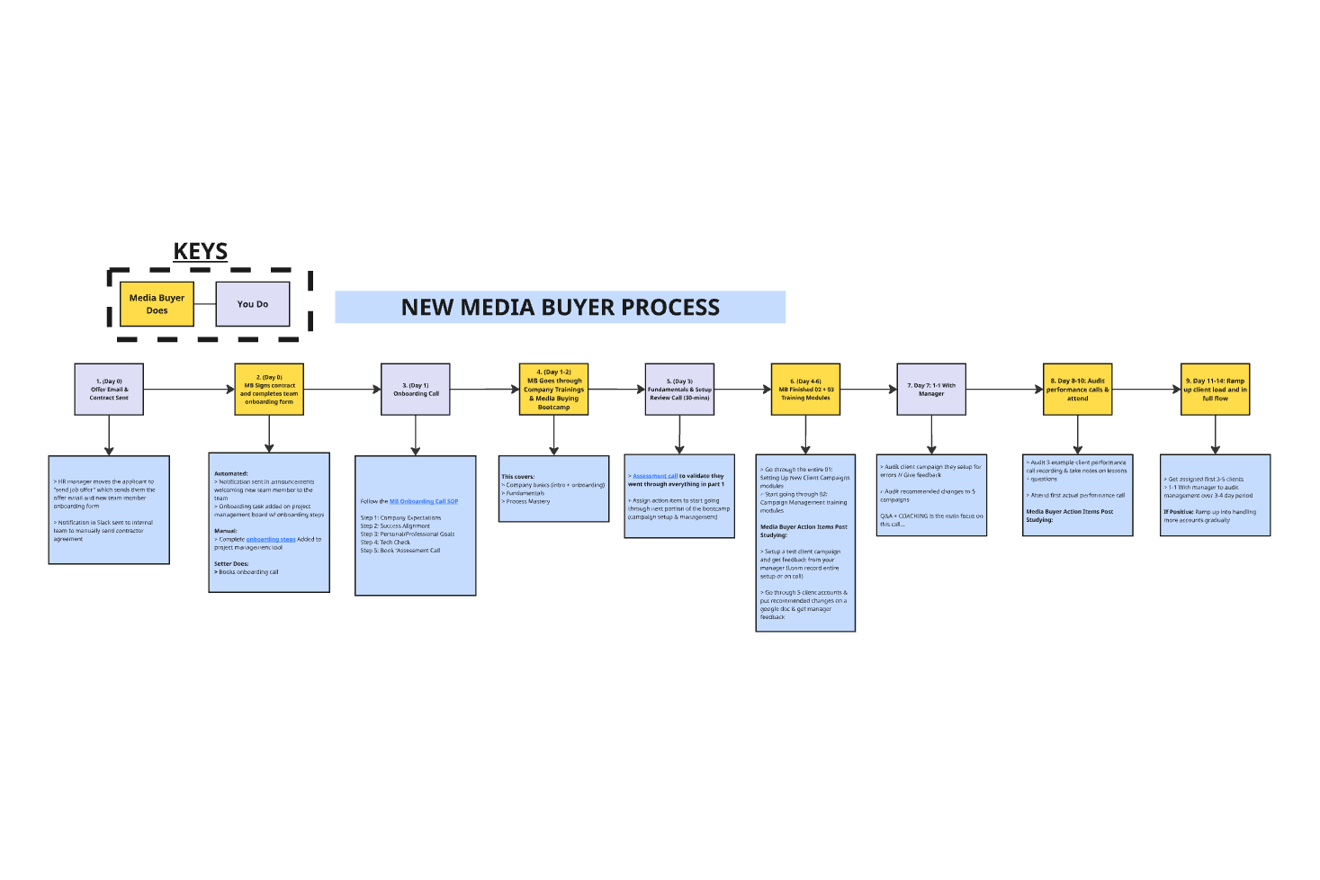
- Day 0: Offer Sent & Contract Signed
  - The moment the contract is signed, we immediately start onboarding the new team member following our Media Buyer Initial Onboarding Steps SOP to get them access to everything and to get their onboarding call booked.
- Day 1: Onboarding Call
  - This is a quick 30-minute call to welcome them to the team, set expectations, and walk them through the initial steps. You'll follow the Media Buyer Onboarding Call SOP for this.
- Day 1-2: Company Trainings & Media Buying Fundamentals
  - The media buyer goes through the Entire Team Module (vision, values, mission, core team training, etc.) and the Fundamentals Folder in the Media Buyer Bootcamp (the 5-10 core videos on the basics of their role). This is the foundational knowledge they need before they can touch a client campaign.
- Day 3: Fundamentals & Setup Assessment Call with Manager
  - After completing the fundamentals, they have an Assessment Call with you to validate they've understood everything. If you're more than a 7/10 on their ability, move them to start setting up test campaigns; if not, have them re-go through the training again.
- Day 4-6: Setup & Serve Review Call with Manager
  - Go through campaign setup & management trainings then complete the following:
    - Setup a test client campaign and get feedback from your manager (Loom record entire setup or on call)
    - Go through 5 client accounts & note down recommended changes on a google doc & get manager feedback
- Day 7: 1-1 Work Manager
  - Audit client campaign they setup & give feedback
  - Audit recommended changes to 5 campaigns doc they made
    - Focus this call on coaching and answering any relevant questions the MB may have
- Day 8-10: Audit performance calls & shadow
  - Listen to 3 client performance call reviews and create google doc w/ takeaways from each
  - Attend first client performance call + take detailed notes
    - Once done: they will then setup their first NEW actual client campaign
- Day 11-14: Ramp Up Client Load and Hit KPI Flow
  - Day 11 we assign the first 3-5 clients to them to officially start managing active clients
  - Day 14: check in call to audit changes made to those clients and do any necessary coaching
  - Gradually ramp the media buyer up from here to day 30 to managing 30-50 client campaigns

- Here’s a full breakdown of the ramp up in detail from one day to the next:
  - Media Buyer - Ramp-Up Process
  - Media Buyer 30 Day Ramp Up Checklist

The 3 Pillars of Media Buyer Success
Training a new media buyer is like a builder building a house. You wouldn't just throw them some wood and metal and wish them good luck. You need to provide a blueprint, the right tools, and a project manager to keep them on track. The same applies to your media buyers. There are three key pillars to their success:

- Show Them What Success Looks Like (Clarity)
  - They need to know exactly what's expected of them - their role, their KPIs, what "winning" looks like for them, for the clients, and for you.
    - For example: "Your mission is to manage 20-30 client campaigns, keep CPL below $12 and schedule rate above 10%, refresh ads every 3-4 days, and communicate proactively with CSMs when campaigns are out of KPI. You will do this by following our systems, using our content drive, and taking detailed notes on all updates."
- Give Them the Resources They Need to Win (Tools & Training)
  - This means access to all your systems (Monday.com, GHL, Fathom, Slack), all your SOPs, all relevant client info, and a structured training program - the bootcamp we're about to build.
- Give Them the SUPPORT They Need to Stay on Track (Guidance & Accountability)
  - Regular check-ins, 1-on-1s, team meetings, and clear access to you or a manager when they have questions or hit a wall.
  - I compare training team members to kinda like a builder building a house. We give them the resources to build the house, but we wouldn't just throw them some wood and metal and wish them good luck. We give them a BLUEPRINT (clarity), we make sure they have the right tools (resources), and have regular check-ins with the project manager (support...)

The Media Buyer Training Bootcamp
The key thing that allows us to speed up this entire process is our Media Buyer bootcamp. The bootcamp is structured in folders, and each folder contains modules that the media buyer needs to complete.

They should complete one folder at a time - this way they're not getting overloaded with new information but not knowing how to implement it. Instead, we have them learn one specific thing related to the role, then we validate that they understand how it works, then we have them do it in real time.

Only once this is done do we move on to the next module they need to master or topic to cover.

With every position we start them off by going through the Entire Team Module which everyone goes through, this goes over the following:

Entire Team Modules: To be completed within 1-2hrs MAX:

Folder | Module Name | What To Cover
01: General | 01: Vision | Company vision
 | 02: Core Values | Company core values
 | 03: Mission | Company mission
 | 04: Pay Days & Paid Holidays | Time logistics w/ team members
 | 05: Requesting & Tracking PTO | Logging paid time off and tracking it and allowances
 | 06: How To Submit Anonymous Company Feedback | Anonymous feedback from team members
 | 07: Agency Wiki | Our ChatGPT Agency Wiki - Trained on our company for anyone to use…
02: Tech Stack | 01: Slack | How to navigate/use
 | 02: Google Calendar | How to use/invite people
03: Industry Knowledge | 10: Services We Promote & Industry Lingo | Relevant industry knowledge on what you promote and industry language
 | 11: What Our Ideal Client Looks Like | ICP breakdown
 | 12: Market Research & Must Knows | Competitors & info on our industry
04: Product Knowledge | 13: The Fulfilment System | How we fulfil for our clients

Role Specific Modules: The Media Buyer Bootcamp

This is the core of the training. Below is the full list of modules, what they cover, and whether they are Static (you can use my video) or Dynamic (you need to create your own).

If you ARE NOT well versed in client media buying, I’d strongly recommend you going through this yourself first prior to training a team member on this…

Folder | Module Name | What To Cover | SOP To Copy | Video SOP | Static Or Dynamic?
Fundamentals | 01: Ramp Up Process | This is where we’ll cover their “ramp up process” so they know what to expect from now to being within KPI | Media Buyer 30 Day Ramp Up Checklist  Media Buyer - Ramp-Up Process | Ramp Up Process | Static - Use Mine
 | 02: Mission & Monthly Review | what KPI’s they are expected to hit and their “purpose” and their monthly “scorecard” | Media Buyer Mission  Media Buyer Job Scorecard | Mission & Monthly Review | Dynamic - To Create
 | 03: Daily Workflow & Responsibilities | Breakdown of what they’ll be doing in the day to day | Media Buyer: Daily Workflow & Responsibilities | Daily Workflow & Responsibilities | Dynamic - To Create
 | 04: Do’s and Dont’s | Things to keep in mind - what we look for and what we don't want… | Media Buyer - Do's and dont's | Do’s and Dont’s | Static - Use Mine
 | 05: Computer Setup | Quick computer config action items | Media Buyer: Computer Setup & Essential Tools | Computer Setup | Dynamic - To Create
 | 06: EOD Form | Understanding the report & how to use it correctly | Media Buyer EOD Report | EOD Form | Static - Use Mine
Process Mastery | 01: Client Ads Playbook | Universal training on the psychology of creating good ads | Client Ads Playbook | Client Ads Playbook | Static - Use Mine
 | 02: Finding Winning Ads / Offers | How to “Competition Hack” to find industry specific winning ads & offers | Facebook Ads Spytool | Finding Winners | Static - Use Mine
 | 03: Systems Overview | Breakdown of all tools & platforms used relevant to the media buying position | Media Buyer: Systems Overview | Systems Overview | Dynamic - To Create
 | 04: Campaign & Funnel Structure | Breakdown of how our client campaigns are structured & the lead journey | Campaign & Funnel Structures | Campaign & Funnel Structure | Dynamic - To Create
 | 05: Advertising Guidelines (Andromeda) | Education video on the new Meta Andromeda update | The New Rules of Meta Advertising - Andromeda | Andromeda Training | Static - Use Mine
01: Campaign Setup | 01: New Campaign Setup | Step by step breakdown of how to setup a new client campaign |  | Onboarding Process & Steps A-Z | Depends
 | 02: Backup Ad Accounts | What a backup ad account is and when we use them | How to Use Backup Ad Accounts | Backup Ad Accounts | Depends
02: Campaign Management | 01: Diagnosing & Fixing Campaign Constraints | How to fix client performance issues | Diagnosing & Fixing Constraints | Diagnosing & Fixing Campaign Constraints | Dynamic - To Create
 | 02: Approval Process (For Changes) | Process prior to going live with new ads // offers |  | Ad Approval Process | Depends
 | 03: Testing Process | How to double down on winners and testing ads correctly | Ad Testing Process - How to Test Ads and Find Winners | Ad Testing Process | Depends
 | 04: Reporting 🚩 Campaigns | How to identify big ad issues and the process for reporting them | Reporting Red Flag Campaigns | Reporting 🚩 Campaigns | Static - Use Mine
 | 05: Live Ad Audits | Live audit of fixing client campaign issues and auditing them | NA | Live Ad Audits | Depends
 | 06: Additional Tools | Extra AI tools media buyers can use to be more efficient | AI Tools for Media Buyers | AI Tools for Media Buyers | Static - Use Mine
 | 07: Communicating With Clients | How to communicate with clients as a MB | Media Buyer Communication Guide - Text Templates | Communicating With Clients | Depends
 | Checkpoint: Study Performance Calls | Study 3-5 different client performance calls and take notes | NA | Example Performance Call | Dynamic - To Create
03: Making Ad Creatives | 01: Image Ad Creation | How to make Image ads using AI | Image Ad Creation SOP | Image Ad Creation | Depends
 | 02: AI Voiceover B-Roll Ads | How to make voiceover video ads using AI | B2C Voiceover B-Roll Ads SOP | AI Voiceover B-Roll Ads | Depends
 | 03: Shared Screen AI Ads | How to make shared screen video ads using AI | Shared Screen AI Ads SOP | Shared Screen AI Ads | Depends
 | 04: Transformation AI Ads | How to make transformation video ads using AI | Transformation AI Ads SOP | Transformation AI Ads | Depends
 | 05: Talking Head / Testimonial AI Ads | How to make talking head video ads using AI | Talking Head / Testimonial AI Ads SOP | Talking Head / Testimonial AI Ads | Depends
04: Facebook Guides | 01: Fixing Common Facebook Issues | How to solve most common FB issues | Fixing Common FB Issues | Fixing Common Facebook Issues | Static - Use Mine
 | 02: New BM Setup Process | How to setup a new business manager | New Business Manager Setup | New BM Setup Process | Static - Use Mine
We segment the content as shown into company general and role specific - the general one I’ll be diving into more in the “team management & leadership” modules, but for now what you need to focus on is the role specific modules.

Platforms & Tools
There’s 3 key things you need when making bootcamps, you need 1. somewhere to house the content that your team can watch on 2. A tool to record the content 3. A tool to write out the written sop format, here’s my recommendations:

- Skool: This will be where you house your videos and where your team can watch the bootcamp content
- Loom: This is what you’ll use to record the videos, this integrates directly with skool so you can immediately upload a link
- Google Docs: Pretty self explanatory, it’s exactly what I'm using right now

The reason I'm a fan of these tools over anything else is because for the hosting platform, I’ve tried to use Monday, Clickup, Kajabi - I just personally found that Skool is the most user friendly, now if you’re looking for an option that's free and similar to Skool, I’d recommend using GHL as they recently brought out an exact copy of skool that's included in GHL’s plan.

For recording you CAN manage videos on Wistia, Vimeo etc - Loom is just cheaper, easier to record, and will save you time downloading and uploading content to a video hosting platform. Just use loom it’ll make your life 10x easier.

Copy My Bootcamp

People think building out a bootcamp like this is going to take weeks or months, realistically you can create the entire thing in 3-7 days max if you leverage AI, already have previous call recordings, and just replicate the framework I’ve given you.

Here’s how to speed up building this out:
- Before you RECORD a video, watch the video I’ve already made for that module specifically
  - I added all internal SOP’s we use above on this document with the written SOP’s too
  - With some of the static videos (SOP’s that will stay the same throughout) you can just License my exact SOP on this so you don't have to recreate it, I’ve organized all videos above with what you need to re-create and what you don’t under the “use my video or not” column

- Use the SOP creation AI
  - I’ve made an AI already trained our all of my internal resources and how to structure everything correctly, so use this when making a module if its different to something I have already built

- Use this SOP template document: Untitled document
  - Put this in your “template gallery” and use it each time you make an SOP so the format is the same for all videos

Let me give you a rundown of how to set this up using skool.com so you understand my creation process… (in the video I show how to set everything up live)

The 3+ Rule
You’ll find that overtime there will be new questions, new mistakes, new confusions with the more Media Buyers you bring onto your team and that's why building this bootcamp is more of an ongoing process than a one and done. Majority of the work is going to be done in the initial buildout, but then after that point you will need to either add new content or update existing content, here’s my process for doing so:

If my team asks the same question 3+ times or makes the same mistake repeatedly, I make a video…

